Quentin H. Childs

SDC445L

12/8/2024

## 5.3 Final Project

## Test and Deploy

* Title of application

TaskMaster Pro

* Dates worked on application

Nov. 27

* Tasks accomplished

Rearranging the website and reorganizing the format

This version adds a more “modern” look to the webpage.

Transferring from the look of last week’s to the new look.

Adding a multiple functions to the website

Website has become more “enhanced”

Added testimonials’ section

The functions section introduces three key features: Task Management, Project Tracking, and Reporting, each with a brief description.

* Challenges faced and the solutions you implemented

The only challenge I faced was getting the approximate code in order to make the webpage look exactly like I wanted.

Making the background contrast with the color of the lettering

* Plans for the upcoming week

N/A.

* Outside resources utilized

Copilot Instructionals.

* Screenshots that show the progress from your plan until this final week

BEFORE

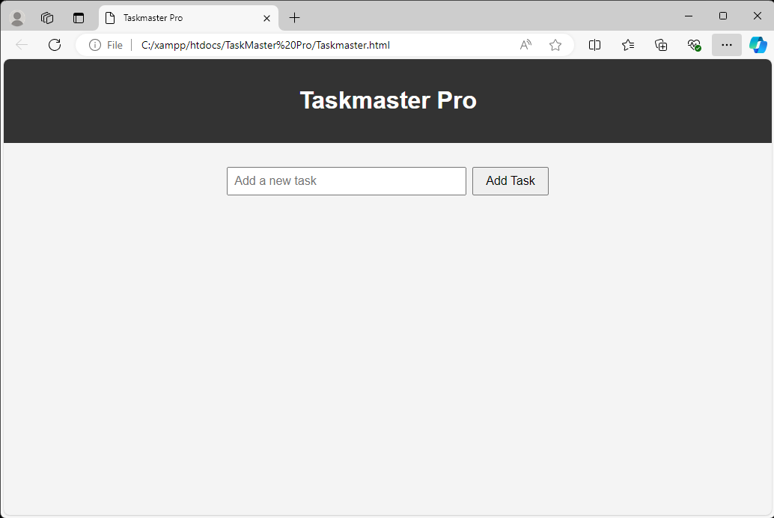

AFTER

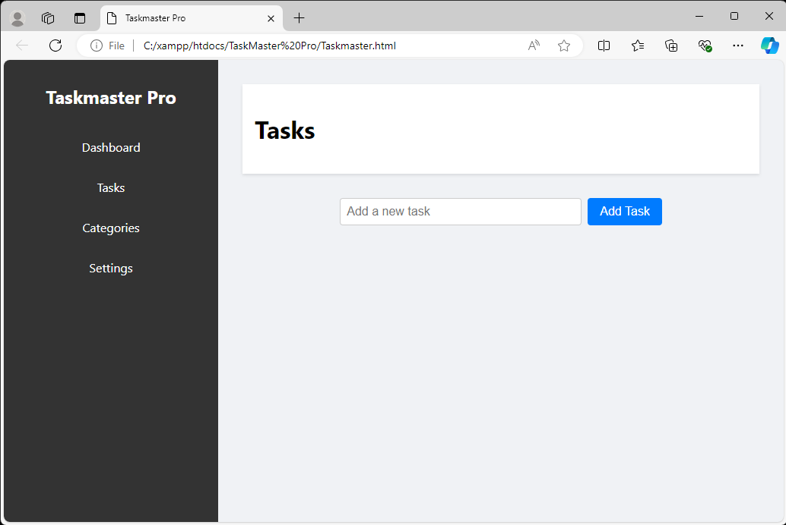

11/27

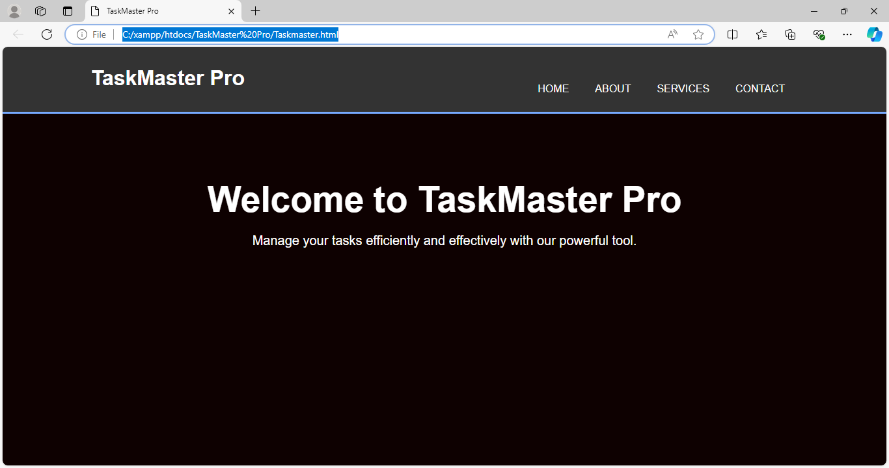

Week 5

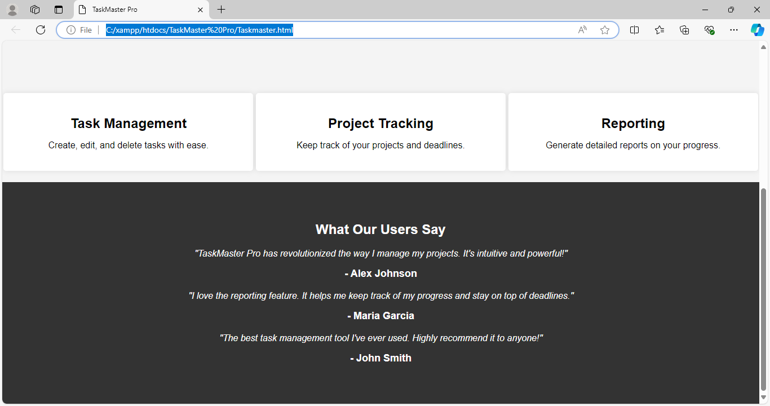

Code for the Final Product.

<!DOCTYPE html>

<html lang="en">

<head>

<meta charset="UTF-8">

<meta name="viewport" content="width=device-width, initial-scale=1.0">

<title>TaskMaster Pro</title>

<style>

body {

font-family: 'Arial', sans-serif;

background-color: #f4f4f4;

margin: 0;

padding: 0;

}

.container {

width: 80%;

margin: auto;

overflow: hidden;

}

header {

background: #333;

color: #fff;

padding-top: 30px;

min-height: 70px;

border-bottom: #77aaff 3px solid;

}

header a {

color: #fff;

text-decoration: none;

text-transform: uppercase;

font-size: 16px;

}

header ul {

padding: 0;

list-style: none;

}

header li {

float: left;

display: inline;

padding: 0 20px 0 20px;

}

header #branding {

float: left;

}

header #branding h1 {

margin: 0;

}

header nav {

float: right;

margin-top: 10px;

}

.showcase {

min-height: 400px;

background: url('your-image.jpg') no-repeat center center/cover;

text-align: center;

color: #fff;

}

.showcase h1 {

margin-top: 100px;

font-size: 55px;

margin-bottom: 10px;

}

.showcase p {

font-size: 20px;

}

.functions {

display: flex;

justify-content: space-around;

margin-top: 20px;

flex-wrap: wrap;

}

.function {

background: #fff;

padding: 20px;

border-radius: 5px;

box-shadow: 0 0 10px rgba(0, 0, 0, 0.1);

width: 30%;

text-align: center;

margin-bottom: 20px;

}

.function h2 {

margin-bottom: 10px;

}

.function p {

font-size: 16px;

}

.testimonials {

background: #333;

color: #fff;

padding: 50px 0;

text-align: center;

}

.testimonial {

margin-bottom: 20px;

}

.testimonial p {

font-style: italic;

}

.testimonial h3 {

margin-top: 10px;

font-size: 18px;

}

@media (max-width: 768px) {

header nav {

float: none;

text-align: center;

}

header li {

float: none;

display: block;

padding: 10px 0;

}

.showcase h1 {

font-size: 40px;

}

.showcase p {

font-size: 18px;

}

.function {

width: 45%;

}

}

@media (max-width: 480px) {

.container {

width: 100%;

padding: 0 10px;

}

.showcase h1 {

font-size: 30px;

}

.showcase p {

font-size: 16px;

}

.function {

width: 100%;

}

}

</style>

</head>

<body>

<header>

<div class="container">

<div id="branding">

<h1>TaskMaster Pro</h1>

</div>

<nav>

<ul>

<li><a href="#">Home</a></li>

<li><a href="#">About</a></li>

<li><a href="#">Services</a></li>

<li><a href="#">Contact</a></li>

</ul>

</nav>

</div>

</header>

<section class="showcase">

<div class="container">

<h1>Welcome to TaskMaster Pro</h1>

<p>Manage your tasks efficiently and effectively with our powerful tool.</p>

</div>

</section>

<section class="functions">

<div class="function">

<h2>Task Management</h2>

<p>Create, edit, and delete tasks with ease.</p>

</div>

<div class="function">

<h2>Project Tracking</h2>

<p>Keep track of your projects and deadlines.</p>

</div>

<div class="function">

<h2>Reporting</h2>

<p>Generate detailed reports on your progress.</p>

</div>

</section>

<section class="testimonials">

<div class="container">

<h2>What Our Users Say</h2>

<div class="testimonial">

<p>"TaskMaster Pro has revolutionized the way I manage my projects. It's intuitive and powerful!"</p>

<h3>- Alex Johnson</h3>

</div>

<div class="testimonial">

<p>"I love the reporting feature. It helps me keep track of my progress and stay on top of deadlines."</p>

<h3>- Maria Garcia</h3>

</div>

<div class="testimonial">

<p>"The best task management tool I've ever used. Highly recommend it to anyone!"</p>

<h3>- John Smith</h3>

</div>

</div>

</section>

</body>

</html>